

Engineering Applications of Artificial Intelligence 162 (2025) 112333
Contents lists available at ScienceDirect

Engineering Applications(应用) of Artificial Intelligence
journal homepage: www.elsevier.com/locate/engappai


Research paper
An /adaptive hybrid /machine reading /comprehension framework for multimodal emotion-cause pair extraction in conversations
针对对话中的多模态情感-原因配对抽取问题,提取出一种自适应混合式机器学习框架。
Guorui Li ^{a,b}, Xufeng Duan ^{b}, Cong Wang ^{b}, Sancheng Peng ^{c,∗}
a Laboratory of Language and Artificial Intelligence, Center for Linguistics and Applied Linguistics, Guangdong University of Foreign Studies, Guangzhou 510420, China

b School of Computer Science and Engineering, Northeastern University, Shenyang 110819, China
c Laboratory of Language Engineering and Computing, Guangdong University of Foreign Studies, Guangzhou 510006, China

A R T I C L E I N F O
文章信息 A B S T R A C T

Dataset link: https://github.com/liguorui77/A HMRC

Keywords:
Sentimental analysis
Emotion-cause pair extraction Multimodal fusion
Conversation
Multimodal emotion-cause pair extraction in conversations (MECPEC) has gradually evolved into an emerging task aimed at discovering deeper causal relationships between emotions and their corresponding causes in conversational contexts. It has widespread application in fields such as human–computer interaction, social media analysis, customer feedback management, and empathetic companion, among others. However, the challenges posed by the oversimplified multimodal feature fusion mechanism and the failure to account for the relative positional relationship between emotions and causes still hinder the performance of MECPEC. In this study, we propose an adaptive hybrid machine reading comprehension (AHMRC) framework to extract potential emotion-cause pairs inherent in conversations. The MECPEC task is first transformed into a two-round hybrid machine reading comprehension task that sequentially enforces the global emotion query and the local cause query with the goal of exploring the relative position constraint specific to conversations. Subsequently, an adaptive multimodal attention module is designed by incorporating features extracted from text, video, and audio modalities, and adaptively fusing them according to their contributions. Extensive experiments were carried out on the benchmark datasets to demonstrate the effectiveness of the proposed AHMRC framework in comparison to other state-of-the-art methods in the literature.

Introduction

In daily life, people communicate with each other through conversation, which is a fundamental way to exchange information, share ideas, express feelings, and build relationships (Yang et al., 2024; Li et al., 2025b). Within these conversations, rich emotions and their underlying causes are often embedded, reflecting the nuanced dynamics of human interaction (Wang et al., 2023; Su et al., 2023). By extracting these emotion-cause (E–C) pairs, we can uncover deeper semantic insights hidden in conversational data, which has broad applications, including human–computer interaction, social media analysis, customer feedback management, and empathetic companion, among others (Peng et al., 2024; Fu et al., 2025a).
In essence, conversational data is inherently multimodal, encompassing text, video, and audio modalities. Among these, conversational dialogue is primarily represented in the text modality, serving as a rich and accessible source of emotional and causal information (Jain et al., 2024b). The text component captures explicit linguistic cues, such as word choice and sentence structure, that convey emotions and
their underlying causes. Meanwhile, the video modality contains rich visual cues, including facial expressions, gestures, and body language, while the audio modality encapsulates vocal features such as tone, intonation, and pitch (Fu et al., 2025b). Together, these modalities provide complementary insights into the emotional and causal dynamics of human interactions, enabling a more holistic understanding of conversations (Quan et al., 2024).
Current research focuses primarily on the textual emotion-cause pair extraction (ECPE) task (Zhou et al., 2022; Song et al., 2023; Cheng et al., 2023; Mai et al., 2024). Although a number of ECPE methods have been proposed in the literature, they use only the textual information to infer emotions and their corresponding causes. Recently, several approaches have been developed specifically for emotion-cause pair extraction in conversations (ECPEC) (Li et al., 2023a; Liu et al., 2023a). However, these methods overlook the valuable information embedded in video and audio modalities. As a related sentimental analysis task, emotion recognition in conversations (ERC) aims to identify and classify the emotions expressed by participants during a conversation (Tsai et al., 2019; Hu et al., 2021, 2022a,b; Li et al., 2023b). It frequently

∗ Corresponding author.
E-mail addresses: lgr@neuq.edu.cn (G. Li), psc346@aliyun.com (S. Peng).

https://doi.org/10.1016/j.engappai.2025.112333
Received 2 July 2025; Received in revised form 21 August 2025; Accepted 12 September 2025
Available online 24 September 2025
0952-1976/© 2025 Elsevier Ltd. All rights are reserved, including those for text and data mining, AI training, and similar technologies.

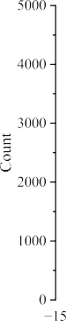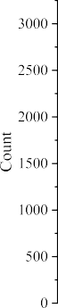

/ig. 1. The distribution of distance between emotions and causes in conversations.

utilizes multimodal data to capture the full spectrum of emotional cues, but the underlying causes behind the identified emotions cannot be obtained by ERC simultaneously (Xiang et al., 2025).
Recently, multimodal emotion-cause pair extraction in conversations (MECPEC) has gradually gained attention in the literature, marking a significant shift toward leveraging multimodal data for more comprehensive emotion-cause pair extraction (Li et al., 2024). This advancement has led to the development of several innovative MECPEC methods, including MECPE-2steps (Wang et al., 2023) and UniMEEC (Hu et al., 2024), accompanied by the release of specially annotated
datasets, such as emotion-cause-in-friends (ECF) and conversational emotion-cause pair extraction (ConvECPE), to support this evolving research direction. By carefully examining these methods, we identify the following technical challenges that are still posing in the MECPEC task:
- The absence of an effective multimodal fusion mechanism for MECPEC constitutes a critical limitation. It is imperative to investigate more sophisticated and effective approaches to fuse multimodal features and enhance the performance of the MECPEC task. Over-simplified approaches, such as concatenation or
element-wise addition of multimodal features, frequently fail to capture the complex interactions and dependencies between different modalities, resulting in suboptimal outcomes (Wang et al., 2023; Shi and Huang, 2023).
- The relative positions between emotions and causes in conversations are often overlooked. As a fundamental form of daily oral communication, conversations tend to have a simple and intuitive structure. Consequently, the distance between emotion and its cause is generally limited, facilitating a clearer and more immediate connection between the two (Li et al., 2023a; Tu et al., 2024). For illustration, we show the distribution of distances between emotions and causes for ECF and ConvECPE in Fig. 1. It is clear that most E–C pairs are in a limited range compared to the full length of conversation.
To address the aforementioned issues, we propose an adaptive hybrid machine reading comprehension (AHMRC) framework for extracting E–C pairs from multimodal conversations. The illustration of the proposed AHMRC framework is shown in Fig. 2. For each modality, the corresponding modality-related features are extracted using a specific encoder in the multimodal feature extraction step. Then, the textual, video and audio features are correlated and adaptively fused according to their contributions in the adaptive multimodal fusion step. By asking the global emotion query ‘‘Is it an emotion utterance?’’ and the local cause query ‘‘Is it a cause utterance corresponding to 𝑢𝑖?’’ in
the two-round hybrid machine reading comprehension (MRC) step, we infer the emotion utterance 𝑢𝑖 and its cause utterance 𝑢𝑗 in the global and local scopes, respectively. Finally, the E–C pair (𝑢𝑖, 𝑢𝑗 ) is obtained and regarded as the extracted result.
By fusing the multimodal features adaptively and executing the global and local queries in a two-round hybrid MRC mode, the aforementioned challenges could be addressed correspondingly. In summary, the main contributions of our proposed AHMRC framework are as follows:
- We design an adaptive multimodal attention module that incorporates features from multiple modalities and fuses them according to their contributions adaptively.
- We transform the MECPEC task into a two-round hybrid MRC task by enforcing the global emotion query and the local cause query to take advantage of the relative position constraint specific to conversations.
- We conduct extensive experiments on the ECF and ConvECPE datasets to evaluate the performance of our proposed AHMRC framework in comparison with other textural ECPEC, Multimodal ERC, and multimodal ECPEC methods.
The remainder of this paper is organized as follows. Section 2 offers a review of existing ERC and ECPEC methods from the literature. Section 3 provides an in-depth elaboration on the proposed AHMRC framework. Section 4 presents the experimental results, including performance comparisons, hyper-parameter analysis, and case study. Finally, Section 5 concludes the paper and outlines potential directions for future research.

Related work

  - Emotion recognition in conversations

As a critical sentimental analysis task, ERC aims to identify the underlying emotions expressed by the participating speakers in a conversation (Jain et al., 2024a). In multimodal ERC settings, textual, video, and audio data offer distinct yet complementary insights into the emotional states of the speakers (Gan et al., 2024). By effectively integrating and leveraging these diverse modalities, we can enhance the accuracy and robustness of the recognized emotions. Current research on ERC focuses on the context construction, speaker dependency establishment, and multimodal feature fusion.
When constructing contextual structure between utterances in a conversation, researchers typically employ techniques such as sliding windows and hierarchical models. Representative methods for context construction in ERC include DialogueGCN (Ghosal et al., 2019),

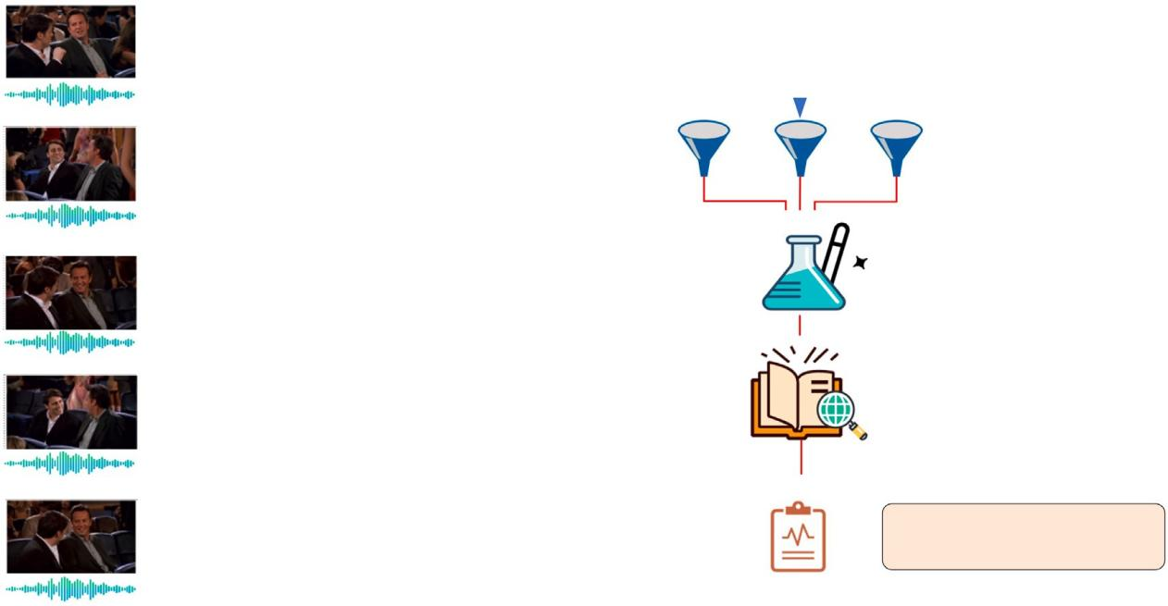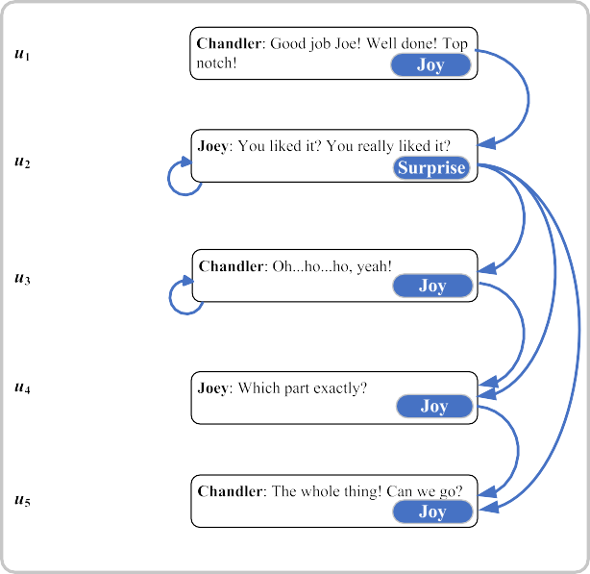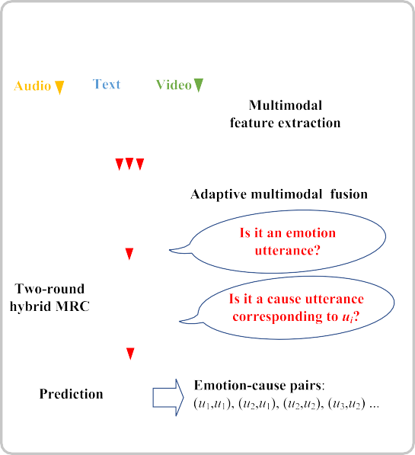

/ig. 2. The illustration of the AHMRC framework.

MMGCN (Hu et al., 2021), MMDAG (Xu et al., 2022), and HiDia-log (Liu et al., 2023c), among others. With regard to establishing speaker dependency, both intra-speaker and inter-speaker dependencies are created simultaneously to better reflect the temporal order and representational relationship of utterances. Representative solutions include MM-DFN (Hu et al., 2022a), MuCDN (Zhao et al., 2022), SGED (Bao et al., 2022), and COGMEN (Joshi et al., 2022), etc. As for multimodal feature fusion, the integration of visual and audio information into textual features is typically achieved through the utilization of graph-based structures or cross-attention mechanisms. Representative approaches that have been proposed include GraphMFT (Li et al., 2023c), MultiEMO (Shi and Huang, 2023), SACCMA (Guo et al., 2024), and FrameERC (Li et al., 2025b), etc.

  - Emotion-cause pair extraction
The emotion-cause pair extraction task was first coined by Xia et al. in Xia and Ding (2019) to overcome the emotion pre-specification problem in the emotion-cause extraction (ECE) task. Its goal is to extract all emotion-cause pairs simultaneously without pre-specifying the underlying emotions. In pair-level ECPE methods, all emotion and cause utterances are typically selected separately and then combined together in a Cartesian product form. Although simple and easy to implement, error accumulation and a high ratio of invalid E–C pairs to valid ones limit its performance. Representative methods of this category include ECPE-2D (Ding et al., 2020a), RANKCP (Wei et al., 2020), and
and published the first MECPEC datase, i.e., ECF, in Wang et al. (2023). Concurrently, a deep learning-based MECPEC-2steps method was proposed at the same time, which extracts E–C pairs in a pair-level mode. Furthermore, Hu et al. developed a unified multimodal emotion recognition and cause analysis (UniMEEC) framework by utilizing the multimodal causal prompting under the cross-task and cross-modality settings in Hu et al. (2024). Ma et al. proposed the MultiCauseNet framework by incorporating graph attention networks and Transformers to effectively model the intra-modal and inter-modal dependencies among multiple modalities (Ma et al., 2025). Recently, Li et al. designed HiLo to extract holistic interaction and label constraint features via attention mechanisms and further enhanced the causal inference through extracting emotion transition features (Li et al., 2025a).
In light of the recent emergence of the MECPEC task, the extant literature on effective multimodal fusion mechanisms and efficient relative positional queries remains limited. In this study, we propose the AHMRC framework, which incorporates an adaptive multimodal attention module and hybrid emotion and cause queries to further enhance the performance of the MECPEC task.

Methodology

  - Problem formulation
{ | |}

Given a conversation 𝐷 = 𝑢1, … , 𝑢𝑖, … , 𝑢 𝐷 , where each utterance
𝑢𝑖 consists of text component 𝑢^{𝑡}, audio component 𝑢^{𝑎}, and video com-
𝑢𝑖
𝑢𝑖, 𝑢𝑖 , 𝑢𝑖

ponent
PairGCN (Ding et al., 2020b), among others. Subsequently, sequence
𝑢𝑖
^{𝑣}, i.e.,
= { _{𝑡}
_{𝑎} _{𝑣}} 𝑖 𝑖
. The goal of the MECPE task is to extract

tagging methods have been proposed to identify and tag all potential emotion and cause utterances. However, the complicated many-to-one
relationship increases the difficulty. Representative solutions in this

the set of emotion-cause pairs 𝑃 from the conversation 𝐷 as follows:
𝑃 = {⋯ , (𝑢 , 𝑢 ), …} (1)
𝑗
𝑘

category include UTOS (Cheng et al., 2021), BMST (Liu et al., 2023b), and EmoPrompt-ECPE (Gu et al., 2024), etc. Recently, machine reading comprehension (MRC) has been utilized to perform the ECPE task by answering queries through large-scale pre-trained language models. Representative approaches in this category include MM-R (Zhou et al., 2022), CD-MRC (Cheng et al., 2023), and CFC-ECPE (Mai et al., 2024),
etc.
However, the aforementioned methods focus only on the textual modality, overlooking the rich information embedded in the video and audio modalities. Recently, Xia et al. proposed the MECPEC task
where 𝑢𝑗 and 𝑢𝑘 are a pair of emotion and cause utterances, respectively. Note that in practice one emotion utterance may correspond to several cause utterances.

  - AHMRC framework

To extract the emotion-cause pairs from a given multimodal conversation, we design an adaptive hybrid machine reading comprehension framework in this paper. In general, it transforms the MECPE task into a hybrid machine reading comprehension task and adaptively fuses the

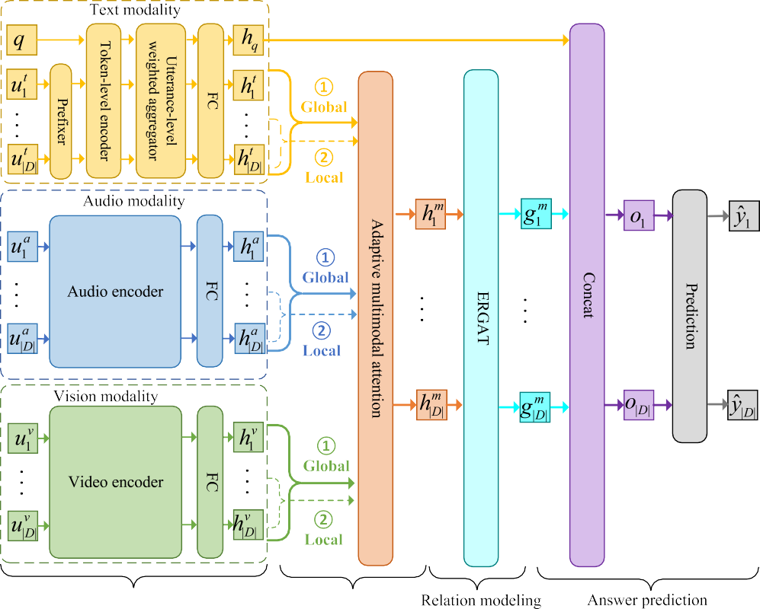

/ig. 3. The adaptive hybrid machine reading comprehension framework.

multimodal features extracted from text, audio, and video modalities. The structure of the AHMRC framework is shown in Fig. 3, which sequentially includes the feature extraction step, the multimodal fusion step, the relationship modeling step, and the answer prediction step. We will introduce them in detail in the following subsections.

    - Feature extraction
For each modality, a modality-specific encoder is utilized to extract the particular features of its input. Different from other formal corpus, the cause utterance in a conversation is usually not far away from its corresponding emotion counterpart. Thus, we design a hybrid two-round MRC task to extract emotion utterances and their cause utterances sequentially.
In the first round, we utilize the global query template to ex-
RoBERTa (Zhuang et al., 2021). Note that 𝑞𝑔 and 𝑞𝑙 are chosen in the first and second rounds of the AHMRC framework, respectively. The input sequence of the token-level encoder is as follows:
𝐼 = {[𝐶𝐿𝑆], 𝑤𝑞,1 , 𝑤𝑞,2 , … , 𝑤𝑞,|𝑞|, [𝑆𝐸𝑃 ], 𝑤1,1 , 𝑤1,2 , … , 𝑤|𝐷|,1 , … , 𝑤|𝐷|,|𝑢̃𝑡 |}
| |𝐷| |
(2)
where [CLS] and [SEP] are the special tokens of the token-level encoder
𝑇 , 𝑤𝑞,𝑘 and 𝑤𝑖,𝑗 are the 𝑘th token of query 𝑞 and the 𝑗th token of the prefixed text-modal utterance 𝑢̃^{𝑡}, respectively. The output sequence of the token-level encoder is as follows:
𝑖
𝐻𝑇 = 𝑇 (𝐼)
= {ℎ , ℎ , ℎ , … , ℎ , ℎ , ℎ , ℎ , … , ℎ , … , ℎ | |}
|𝐷|,|𝑢̃| ||

tract the candidate emotion utterances from the whole conversation. Specifically, we design a global emotion query 𝑞𝑔 ={‘‘Is it an emotion ut-
[𝑐𝑙𝑠]
𝑞,1
𝑞,2
𝑞,|𝑞|
[𝑠𝑒𝑝]
1,1
1,2
|𝐷|,1
𝑡
𝐷
(3)

terance?’’} and ask the question to each utterance 𝑢𝑖 to decide whether it is an emotion utterance. Then, we utilize the local query template
where ℎ

[𝑐𝑙𝑠]
and ℎ

[𝑠𝑒𝑝]
are the hidden representations of [CLS] and

to extract the candidate cause utterances from the context of each extracted emotion utterance 𝑢𝑖 in the second round. Specifically, we design a local cause query 𝑞𝑙 ={‘‘Is it a cause utterance corresponding to
𝑢 ?’’} and ask the question to each utterance 𝑢 in a restricted utterance
[ ]
𝑖
𝑗
window
to select the cause utterance of 𝑢𝑖, where
[SEP], ℎ𝑞,𝑘 and ℎ𝑖,𝑗 are the hidden representations of tokens 𝑤𝑞,𝑘 and
𝑤𝑖,𝑗 , respectively. After that, we send 𝐻𝑇 to a utterance-level weighted aggregator to generate the aggregated utterance-level representations. Specifically, let 𝑆𝑖 = {ℎ𝑖,1, … , ℎ𝑖,|𝑢̃𝑡|} be the set of token-level hidden
𝑖
representations for the prefixed utterance 𝑢̃𝑖. We compute its aggre-
𝑡

𝑤 is a hyper-parameter to control the window size. The local cause inference mechanism can not only greatly reduce the computational cost by narrowing the search scope, but also ensure the accuracy of E–C
𝑢𝑖−𝑤, … , 𝑢𝑖, … , 𝑢𝑖+𝑤
gated utterance-level hidden representation in the following weighted sum form:
∑|𝑢̃𝑖 |
𝑡
ℎ̄ =

pair extraction by avoiding the interference of long-distance irrelevant information.
𝑡
𝑖
𝑗=1
𝛼𝑗 ℎ𝑖,𝑗 (4)

For the text modality, we first prefix each text-modal utterance 𝑢^{𝑡} where
𝑖

with the name of its speaker 𝑠𝑖. That is, let the prefixed text-modal
utterance be 𝑢̃^{𝑡}
= 𝑠𝑖 ∶ 𝑢^{𝑡}, where : is the speaker concatenation
𝑗
𝑖,𝑗
𝛼 = 𝑠𝑜𝑓𝑡𝑚𝑎𝑥 (𝑤^{𝑇} ℎ + 𝑏) (5)

operator. Then, we send the query 𝑞 ∈ {𝑞𝑔, 𝑞𝑙} and these prefixed text-
𝑖
𝑖
is the weighting coefficient for ℎ
, 𝑤 and 𝑏 are the learnable weight

modal utterances { 𝑡 𝑡 … 𝑡 } to a token-level encoder , such as
𝑢̃ , 𝑢̃ ,
, 𝑢̃
𝑇
and bias, respectively. Finally, we pass
𝑖,𝑗

{̄ 𝑡 ̄ 𝑡 … ̄ 𝑡 }
ℎ , ℎ ,
, ℎ
through a fully

1 2 |𝐷| 1 2 |𝐷|

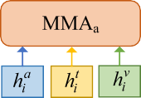
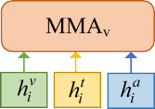
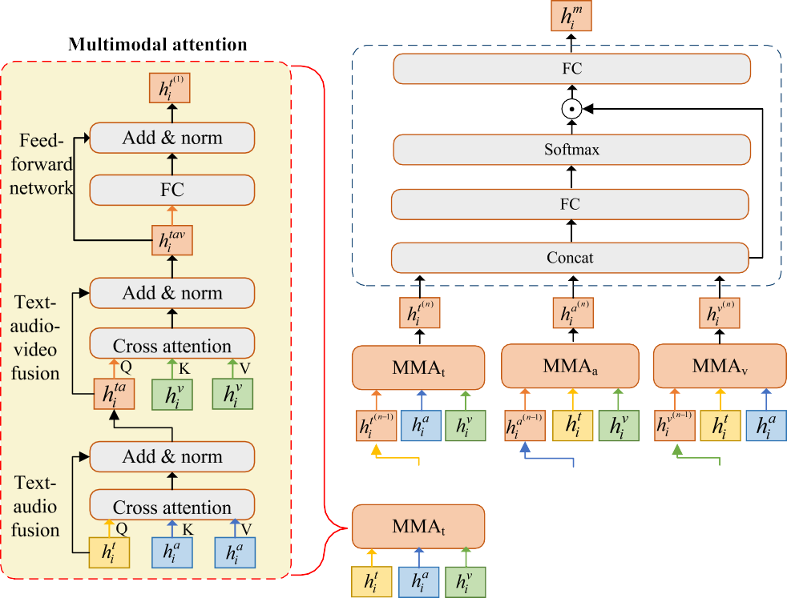
/ig. 4. The adaptive multimodal attention module.

connected layer to reduce its dimensionality to a fixed length 𝑑, such as 256, and obtain the final utterance-level hidden representations
implemented in the same way. In general, MMA_{𝑡} contains the following three components:

𝐻^{𝑡} = {ℎ^{𝑡} , ℎ^{𝑡} , … , ℎ^{𝑡} } for the conversation. Similarly, the utterance-

level 1 2 |𝐷| for the query 𝑞 can be obtained by a similar process. For convenience, we denote it as ℎ𝑞.
hidden representation
For the audio modality, we utilize an audio encoder, such as openS-
MILE,¹ to extract the audio features for each utterance. To facilitate the subsequent multimodal fusion, we further reduce their dimensionality to 𝑑 by a fully connected layer, which is similar to that in the text
modality. For the video modality, we utilize a video encoder, such as
- Text–audio fusion. It learns the cross-modal correlation between text and audio modalities by treating text features as query and audio features as key and value, respectively. The attention result of the 𝑙th head is computed as follows:
⎜⎛ 𝐻𝑡𝑄𝑡𝑎(𝐻𝑎𝐾𝑡𝑎)𝑇 ⎞⎟
_{𝑙} ⎜
√
⎟ _{𝑙}
𝐻^{𝑡𝑎} = 𝑆𝑜𝑓𝑡𝑚𝑎𝑥
𝑙
𝑑
𝑙
𝐻𝑎𝑉 𝑡𝑎
(6)
⎝ 𝑙

C3D (Tran et al., 2015), to extract the spatio-temporal features for each

utterance. For the same reason, a fully connected layer is also applied to
⎜ _{𝐻}𝑎𝐾𝑡𝑎 ⎟⎠

reduce the extracted dimensionality to 𝑑. The final extracted utterance-level audio and video features are denoted as 𝐻^{𝑎} = {ℎ^{𝑎}, ℎ^{𝑎}, … , ℎ^{𝑎} }
the 𝑙
𝑙 𝑙 𝑙
th head in the text–audio fusion,
where 𝑄^{𝑡𝑎}, 𝐾^{𝑡𝑎}, and 𝑉 ^{𝑡𝑎} are the query, key, and value weights of
𝑑𝐻𝑎𝐾𝑡𝑎 is the dimensional-

𝑎 𝑡𝑎 ℎ

and 𝐻^{𝑣} = {ℎ^{𝑣}, ℎ^{𝑣}, … , ℎ^{𝑣}
}, respectively.
1 2 |𝐷|
ity of 𝐻 𝐾ℎ . We then concatenate the attention results of all ℎ
𝑡𝑎

1 2 |𝐷|
heads and multiply them by the weight 𝑂 as follows:

    - Multimodal fusion
In the multimodal fusion step, we adaptively fuse the utterance-level
1
2
ℎ
𝐻̃^{𝑡𝑎} = [𝐻^{𝑡𝑎}; 𝐻^{𝑡𝑎}; ⋯ ; 𝐻^{𝑡𝑎}] 𝑂^{𝑡𝑎} (7)

text, audio, and video features extracted in the previous step by a newly proposed adaptive multimodal attention module. A stacked multi-head cross-attention structure is designed to fuse the multimodal features contained in the conversation and adaptively adjust their contributions, as shown in Fig. 4.
In general, the adaptive multimodal attention module consists of
𝑛 layers of multimodal attention (MMA) submodules and an adaptive fusion (AF) submodule in sequence. With the goal of incorporating features from other modalities, MMA is further subdivided into MMA_{𝑡}, MMA_{𝑎}, and MMA_{𝑣}. They all have the same structure, but focus mainly on the text, audio, and video modalities, respectively. These mixed features are finally sent to the adaptive fusion submodule to measure
where [ ; ] denotes concatenation operation. Finally, a layer norm operation is applied to the residual sum to ensure the stability of the gradient update, i.e.,
𝐻^{𝑡𝑎} = 𝐿𝑎𝑦𝑒𝑟𝑁𝑜𝑟𝑚 (𝐻^{𝑡} + 𝐻̃^{𝑡𝑎}) (8)
- Text–audio–video fusion. It further learns the cross-modality correlation between the above text–audio features and the original video features. This time, 𝐻^{𝑡𝑎} is treated as query, and 𝐻^{𝑣} is treated as key and value, respectively. Its computation process is similar to that of the text–audio fusion, i.e.,
⎛⎜ 𝐻𝑡𝑎𝑄𝑡𝑎𝑣(𝐻𝑣𝐾𝑡𝑎𝑣)𝑇 ⎞⎟
𝑙 ⎜
√
⎟ 𝑙

their contributions and then fused adaptively.
For the sake of brevity, we will only introduce the structure of
𝐻^{𝑡𝑎𝑣} = 𝑆𝑜𝑓𝑡𝑚𝑎𝑥
⎝
1
2
𝑙 𝑙
𝑑𝐻𝑣𝐾𝑡𝑎𝑣
𝑙
𝐻𝑣𝑉 𝑡𝑎𝑣

⎠
(9)

MMA_{𝑡}. By swapping the order of inputs, MMA_{𝑎} and MMA_{𝑣} can be
ℎ
𝐻̃𝑡𝑎𝑣 = [𝐻𝑡𝑎𝑣; 𝐻𝑡𝑎𝑣; ⋯ ; 𝐻𝑡𝑎𝑣] 𝑂𝑡𝑎𝑣 (10)

1 https://github.com/audeering/opensmile
𝐻^{𝑡𝑎𝑣} = 𝐿𝑎𝑦𝑒𝑟𝑁𝑜𝑟𝑚 (𝐻^{𝑡𝑎} + 𝐻̃^{𝑡𝑎𝑣}) (11)

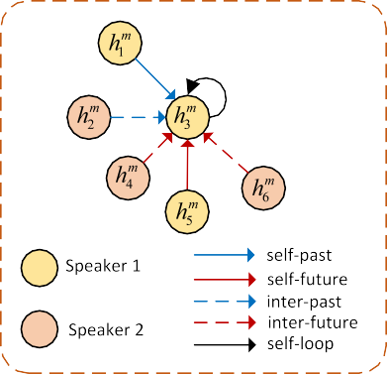
where 𝑄^{𝑡𝑎𝑣}, 𝐾^{𝑡𝑎𝑣}, and 𝑉 ^{𝑡𝑎𝑣} are the query, key, and value weights
𝑙 𝑙 𝑙
of the 𝑙th head in the text–audio–video fusion, 𝑑𝐻𝑣𝐾𝑡𝑎𝑣 is the
𝑙
dimensionality of 𝐻^{𝑣}𝐾^{𝑡𝑎𝑣}.
𝑙

- /eed-forward network. It performs a linear transformation on the extracted multimodal features to enhance the generalization capability of MMA_{𝑡}. Specifically, the fused text–audio–video features 𝐻^{𝑡𝑎𝑣} are sequentially passed through an activation function and a fully connected layer as follows:
𝐹 ^{𝑡𝑎𝑣} = 𝑊𝑓 𝑅𝑒𝐿𝑈(𝐻^{𝑡𝑎𝑣}) + 𝐵𝑓 (12)
where 𝑅𝑒𝐿𝑈 is the rectified linear unit activation function, 𝑊𝑓 and 𝐵𝑓 are the weights and bias of the fully connected layer. Based on the same idea, a layer norm operation is applied to the residual sum as follows:
𝐻^{𝑡}(𝑝) = 𝐿𝑎𝑦𝑒𝑟𝑁𝑜𝑟𝑚(𝐻^{𝑡𝑎𝑣} + 𝐹 ^{𝑡𝑎𝑣}) (13)
where 𝐻^{𝑡}(𝑝) is the final fused multimodal features of MMA in the 𝑝th layer, and the layer index 𝑝 ∈ {1, … , 𝑛}.
𝑡
By stacking 𝑛 layers of MMA , we can obtain the text-leading fused

/ig. 5. The extended relation-aware graph attention network.

- Self-past. It reflects the influence of the previous utterance of the same speaker on the current utterance.

representation 𝐻
𝑡(𝑛)
𝑡
that retains primarily the textual information while
- Self-future. It reflects the influence of the following utterance
of the same speaker on the current utterance.

effectively incorporating relevant audio and visual information at the same time. Similarly, we can obtain the audio-leading fused representa-
tion 𝐻^{𝑎}(𝑛) and the video-leading fused representation 𝐻^{𝑣}(𝑛) by stacking
𝑛 layers of MMA_{𝑎} and MMA_{𝑣}, respectively. These fused features can capture rich cross-modal dependencies and are more suitable for the MECPEC task.
The goal of the adaptive fusion submodule is to fuse the multi-
- Inter-past. It reflects the influence of the previous utterance of other speaker(s) on the current utterance.
- Inter-future. It reflects the influence of the following utterance of other speaker(s) on the current utterance.
- Self-loop. It reflects the influence of the current utterance of the same speaker on itself.

modal features 𝐻^{𝑡}(𝑛) , 𝐻^{𝑎}(𝑛) , and 𝐻^{𝑣}(𝑛) according to their contributions adaptively. Therefore, we first send the concatenation of 𝐻^{𝑡}(𝑛) , 𝐻^{𝑎}(𝑛) ,
Correspondingly, the edge between 𝑣𝑖 and 𝑣𝑗
(
is represented as 𝑒
𝑖𝑗 =

and 𝐻^{𝑣}(𝑛) to a fully connected layer to get the initial fused multimodal
𝑣𝑖, 𝑟𝑖𝑗 , 𝑣𝑗 ). Its weight can be computed using the following attention
mechanism:

features 𝐻̃^{𝑚}, i.e.,
[ ]
𝐻𝑡(𝑛) ; 𝐻𝑎(𝑛) ; 𝐻𝑣(𝑛)
𝛼𝑖𝑗𝑟 = 𝑆𝑜𝑓𝑡𝑚𝑎𝑥
(𝐿𝑒𝑎𝑘𝑦𝑅𝑒𝐿𝑈
(𝑎𝑇
[𝑊𝑟𝐻^{𝑚}; 𝑊𝑟𝐻^{𝑚}
]))
(16)

𝑚1
𝐻̃^{𝑚} = 𝑊
𝑟
𝑖
𝑗
𝑚1
where 𝑊𝑟
and 𝑎𝑟
are the attention weight matrix and vector, re-

where 𝑊𝑚1 and 𝐵𝑚1 are the weights and bias of the first fully connected layer. To further obtain the adaptively weighted multimodal features
+ 𝐵
(14)
𝐻^{𝑚}, we normalize 𝐻̃^{𝑚} along its last dimension using the softmax function and dot-product it with the concatenation 𝐻^{𝑡}(𝑛) ; 𝐻^{𝑎}(𝑛) ; 𝐻^{𝑣}(𝑛) ,
[ ]
spectively. The node representation is updated by aggregating the representations of its neighboring nodes, which are gradually expanded outward.
Let 𝑧^{(𝑙−1)} denote the features of node 𝑖 in the 𝑙 − 1 layer of the
𝑖

followed by another fully connected layer, i.e.,
(0) =
. After constructing ERGAT

ERGAT stack, and its initial value 𝑧𝑖 𝑣𝑖

𝐻^{𝑚} = 𝑊

𝑚2
(𝑠𝑜𝑓𝑡𝑚𝑎𝑥 (𝐻̃^{𝑚}) ⊙ [𝐻^{𝑡}(𝑛) ; 𝐻^{𝑎}(𝑛) ; 𝐻^{𝑣}(𝑛) ]) + 𝐵

𝑚2
(15)
for the conversation, we compute the propagation of the graph node features 𝑧^{(𝑙−1)} under different relation 𝑟. Then, the node features under

where 𝑊𝑚2 and 𝐵𝑚2 are the weights and bias of the last fully connected layer. By adaptively adjusting the importance of each modality, we can
𝑖
all relations are summed up to represent the aggregated features in the next layer, i.e.,

exploit the useful information contained in the text, audio, and video
𝑖
𝑟∈𝑅 𝑗∈𝑁𝑟(𝑖)
𝑖𝑗𝑟
𝑟
𝑗

modalities in a more intelligent way.

𝑧(𝑙) = ∑
∑ 𝛼(𝑙−1)𝑊 (𝑙−1)𝑧(𝑙−1)
(17)

    - Relationship modeling
The classical relation-aware graph attention network (RGAT) is extended with an additional relationship type to represent the notion that the emotion and its cause are in the same utterance. This phenomenon is prevalent, particularly in the MECPEC task. Thus, the performance of E–C pair extraction in conversation can be further improved by
extending this self-relative relationship. The structure of the extended

where 𝑁^{𝑟}(𝑖) is the neighborhood of the 𝑖th node under relation 𝑟, 𝑊 ^{(𝑙−1)} is the weight matrix for relation 𝑟 in the (𝑙 − 1)th layer of the ERGAT stack.
Finally, we concatenate the features of node 𝑖 in the first and last layers to represent the contextual relation-aware features, i.e.:
𝑟
𝑔^{𝑚} = [𝑧⁽⁰⁾; 𝑧^{(𝐿)}] (18)
𝑖
𝑖
𝑖

relation-aware graph attention network (ERGAT) is shown in Fig. 5.
In a conversation, the relationship between utterances associated with their speakers is described in the graph 𝐺 = (𝑉 , 𝐸, 𝑅), where
𝑉 denotes the node set, 𝐸 denotes the edge set, and 𝑅 denotes the relationship type set. Each node 𝑣𝑖 ∈ 𝑉 represents an utterance initialized by the 𝑖th column of the adaptively weighted multimodal features,
i.e., 𝐻^{𝑚}. After passing through a series of ERGAT layers, its features are enhanced by aggregating the representations of its neighboring utterances.
𝑖
Based on the speakers and the temporal order of the utterances in
where 𝐿 is the total number of layers in the ERGAT stack.

    - Answer prediction
For each utterance 𝑢𝑖, we concatenate its contextual relation-aware feature 𝑔^{𝑚} and the hidden representation of the query ℎ𝑞 as follows:
𝑖
𝑜𝑖 = [ℎ𝑞; 𝑔^{𝑚}] (19)
𝑖
Then, the concatenated result is sent to a simple linear layer to predict the result of the query 𝑞. The prediction result is computed as follows:
𝑦̂ = 𝜎 (𝑤 𝑜 + 𝑏 ) (20)
𝑖
𝑝 𝑖
𝑝

𝑒𝑖𝑗 ∈ 𝐸 into the following five categories:
the conversation, we classify the relationship type 𝑟𝑖𝑗 ∈ 𝑅 of each edge
where 𝑤𝑝 and 𝑏𝑝 are the weights and bias, respectively.

  - Joint training

The cross-entropy loss is utilized to measure the prediction error in the joint training process. For the global emotion query 𝑞𝑔, its emotion prediction error is computed as follows:
∑|𝐷|
G𝑔 = −
𝑦𝑖 log 𝑦̂𝑖 (21)

𝑖=1
Table 1
The properties of ECF and ConvECPE datasets.
Dataset | ECF | ConvECPE
Conversations | 1,374 | 151
Utterances | 13,619 | 7,433
E–C pairs | 9,794 | 9,473
E–C pairs w one cause | 4,914 | 2,797
E–C pairs w two causes | 1,724 | 2,108
E–C pairs w three causes | 354 | 820
Training set | 9,666 | 5,810
Validation set | 1,087 | 0
Test set | 2,566 | 1,623

where 𝑦𝑖 and 𝑦̂𝑖 denote the ground truth of the 𝑖th utterance being an emotion utterance and its corresponding predicted result according to Eq. (20), respectively. For the local cause query 𝑞𝑙, its E–C prediction error is computed in a limited utterance window of emotion utterance as follows:
∑|𝑞𝑔 | ∑𝑤
G𝑙 = −
𝑖=1 𝑗=−𝑤
𝑦𝑖,𝑗 log 𝑦̂𝑖,𝑗 (22)

To evaluate the performance of emotion-cause pair extraction, we adopted the metrics of precision, recall, and F1 score, which are calcu-
lated as follows:

where 𝑞𝑔 denotes the number of predicted emotion utterances in the global query stage, 𝑦𝑖,𝑗 and 𝑦̂𝑖,𝑗 denote the ground truth of the emotion-cause relationship between the 𝑖th and the 𝑗th utterances and its corresponding predicted outcome, respectively.
| |
Thus, the total loss of the AHMRC framework is defined as follows:
𝑃 = 𝑝𝑎𝑖𝑟𝑠𝑐𝑟𝑡
𝑝𝑎𝑖𝑟𝑠𝑝𝑟𝑒
𝑅 = 𝑝𝑎𝑖𝑟𝑠𝑐𝑟𝑡
𝑝𝑎𝑖𝑟𝑠𝑎𝑛𝑡
𝐹 = 2𝑃 𝑅
(24)

(25)

(26)

G = G𝑔
+ G𝑙
(23)
1 𝑃 + 𝑅

By iterating over all conversations in the training dataset in multiple epochs, we can update the parameters of the AHMNRC framework through minimizing the loss G using the backpropagation algorithm.

  - Inference

In the inference process, the global query 𝑞𝑔 is first utilized in the AHMRC framework to identify the potential emotion utterances. For each utterance 𝑢𝑖, if 𝑦̂𝑖 is greater than or equal to the predefined threshold 𝜏, it will be identified as an emotion utterance and added to the emotion utterance set 𝐸. Then, for each identified emotion utterance in 𝐸, the local query 𝑞𝑙 is utilized in the AHMRC framework to identify its cause utterance 𝑢𝑗 in a restricted window around 𝑢𝑖. Similarly, if 𝑦̂𝑖𝑦̂𝑖,𝑗 ≥ 𝜏, (𝑢𝑖, 𝑢𝑗 ) will be identified as a valid E–C pair.

Experiments

  - Dataset and metrics

We evaluate the AHMRC framework on the following two datasets, whose properties are shown in Table 1.
- EC/ (Wang et al., 2023). It is a multimodal conversational emotion cause dataset consisting of clips from the sitcom Friends. It was built on the existing MELD dataset (Poria et al., 2019) by annotating the corresponding causes for the following given emotions: anger, disgust, fear, joy, sadness, and surprise. It contains a total of 1,374 conversations, 13,619 utterances, and 9,794 emotion-cause pairs. In the experiment, we follow the settings of Ref. Wang et al. (2023) by splitting the training, validation, and test sets into 9,666, 1,087, and 2,566 utterances, respectively.
- ConvECPE (Li et al., 2023a). It is another multimodal emotion cause dataset consisting of recordings that actors perform improvisations or scripted scenarios. It was constructed on the IEMOCAP dataset (Busso et al., 2008) by annotating the causes of emotions, which include neutral, joy, sadness, anger, excited, and frustration. It contains a total of 151 conversations, 7,433 utterances, and 9,473 emotion-cause pairs. In the experiment, we follow the settings of Ref. Li et al. (2023a) by splitting the training and test sets into 5810 and 1623 utterances, respectively.
where 𝑝𝑎𝑖𝑟𝑠𝑝𝑟𝑒, 𝑝𝑎𝑖𝑟𝑠𝑎𝑛𝑡, and 𝑝𝑎𝑖𝑟𝑠𝑐𝑟𝑡 denote the number of E–C pairs predicted by the model, annotated in the dataset, and correctly predicted
by the model, respectively. Meanwhile, the precision, recall and F1 score of the emotion extraction and the cause extraction are calculated simultaneously as a by-product.

  - Experimental settings

In the experiment, all training and inference tasks were conducted on a server equipped with an NVIDIA 4090 GPU with 24 GB of memory. For the text modality, we utilize RoBERTa-base as the underlying token-level encoder, with a hidden size of 768 and 12 layers. For the audio modality, we first extract sentence-level features using the OpenSMILE toolkit, with each sentence represented by a 6373-dimensional feature vector. Subsequently, a fully-connected layer is applied to reduce the audio features to 768-dimensional vectors. For the video modality, we first employ C3D to extract raw sentence-level features, with each sentence represented by a 4096-dimensional feature vector. The same procedure as for the audio modality is followed, utilizing a fully-connected layer to reduce the video features to 768-dimensional vectors to ensure dimensional consistency across all modalities. The reduced dimensionality 𝑑 of the fully connected layer in the feature extraction step is set to 256. The hyper-parameter 𝑤 for the local query is set to 7 for ECF and 9 for ConvECPE, resulting in a restricted utterance window of size 15 and 19, respectively. For the multimodal fusion step, the number of stacked MMA layers 𝑛 is set to 3 for ECF and 2 for ConvECPE, respectively. Meanwhile, the number of heads ℎ in MMA is set to 4. For the relationship modeling step, the number of stacked ERGAT layers is set to 2.
During the training process, we use the AdamW optimizer with a weight decay of 0.01. Its initial learning rate and warm-up rate are set to 1e-5 and 0.1, respectively. In total, the AHMRC framework is trained for 20 epochs, with a batch size of 2. The early stopping strategy is also adopted to avoid overfitting.

  - Baselines

In the experiment, the AHMRC framework is compared with 14 state-of-the-art baseline methods on the basis of a literature comparison. Since only a limited number of MECPEC methods have been proposed in the literature, we also compare the AHMRC framework with other representative ECPEC and ERC methods. Specifically, these baselines can be classified into the following three categories:

Performance comparison on the ECF dataset.
Methods Emotion extraction Cause extraction E–C pair extraction
 | P | R | F1 |  | P | R | F1 |  | P | R | F1
MM-R | 0.7638 | 0.6849 | 0.7222 |  | 0.6751 | 0.6724 | 0.6737 |  | 0.5129 | 0.4707 | 0.4909
CD-MRC | 0.6784 | 0.7723 | 0.7223 |  | 0.7006 | 0.7672 | 0.7324 |  | 0.4818 | 0.5024 | 0.4919
CFC-ECPE | 0.7249 | 0.6979 | 0.7111 |  | 0.7353 | 0.7047 | 0.7197 |  | 0.5003 | 0.4917 | 0.4960
MulT | – | – | – |  | 0.7515 | 0.7143 | 0.7305 |  | 0.3408 | 0.3785 | 0.3902
MMGCN | – | – | 0.5465ª |  | 0.5651 | 0.5482 | 0.5530 |  | 0.3543 | 0.3819 | 0.3748
MM-DFN | – | – | 0.5486ª |  | 0.5428 | 0.5635 | 0.5517 |  | 0.3790 | 0.3908 | 0.3810
UniMSE | – | – | 0.5637ª |  | 0.5655 | 0.5709 | 0.5673 |  | 0.4448 | 0.5425 | 0.4908
GA2MIF | – | – | 0.5733ª |  | 0.5648 | 0.5833 | 0.5667 |  | 0.4615 | 0.5426 | 0.5016
MECPE-2steps | 0.7745 | 0.8110 | 0.7916 |  | 0.6842 | 0.7243 | 0.7027 |  | 0.5747 | 0.4981 | 0.5320
UniMEEC | – | – | 0.6367ª |  | 0.5987 | 0.5885 | 0.5918 |  | 0.4988 | 0.5929 | 0.5461
MultiCauseNet | – | – | 0.5367 |  | 0.6388 | 0.6283 | 0.6512 |  | 0.5327 | 0.5910 | 0.5512
HiLo | 0.7793 | 0.7626 | 0.7709 |  | 0.6496 | 0.8006 | 0.7172 |  | 0.5306 | 0.5462 | 0.5383
AHMRC | 0.7877 | 0.7565 | 0.7718 |  | 0.7169 | 0.7340 | 0.7270 |  | 0.5928 | 0.5600 | 0.5760
a denotes the weighted F1 score, - indicates not available in the literature.

Textual ECPEC methods.

  - MM-R (Zhou et al., 2022). It designs a document-level machine reading comprehension framework with rethink mechanism to simulate the multi-turn rethink manner of human.
  - CD-MRC (Cheng et al., 2023). It proposes a dual-MRC framework and a set of consistent training strategies to extract E–C pairs in a bi-directional manner.
  - C/C-ECPE (Mai et al., 2024). It utilizes contrastive learning to model the relationship between utterances and employs a counter-factual method to build negative instances for the E–C pair extraction task.
  - Joint-EC(Joint-GCN) (Li et al., 2023a). The graph convolutional network (GCN) is employed to disseminate soft information during the emotion and cause detection step, followed by subsequent extraction of E–C chunks and pairs.
  - Joint-EC(Inter-EC) (Li et al., 2023a). Subsequent to the extraction of emotion and cause utterances according to the Inter-EC method (Xia and Ding, 2019), it further extracts the corresponding E–C chunks and pairs.

Multimodal ERC methods.

  - MulT (Tsai et al., 2019). It uses a multimodal transformer to address the problems of multimodal non-alignment and long-range dependencies through a directional pairwise cross-modal attention mechanism.
  - MMGCN (Hu et al., 2021). It designs a multimodal fused graph convolutional network to incorporate multimodal information and model inter-speaker and intra-speaker relationship, simultaneously.
  - MM-D/N (Hu et al., 2022a). It designs a graph-based dynamic fusion module with the goal of reducing redundancy and enhancing complementarity between multi-modalities.
  - UniMSE (Hu et al., 2022b). It performs modality fusion at both syntactic and semantic levels by simultaneously unifying multimodal sentiment analysis and emotion recognition in conversation from multiple perspectives.
  - GA2MI/ (Li et al., 2023b). In order to model complex cross-modal relationships, it designs a directed graph attention network and a pairwise cross-modal attention network with multi-heads, sequentially.

Multimodal ECPEC methods.
  - MECPE-2steps (Wang et al., 2023). After extracting emotion and cause utterances separately, it constructs a emotion-cause pairing matrix via Cartesian product and then filters out invalid E–C pairs.
  - UniMEEC (Hu et al., 2024). By utilizing the pre-trained large language model, it designs a multimodal causal prompt to implement interactions under the cross-task and cross-modality settings.
  - MultiCauseNet (Ma et al., 2025). It constructs a multimodal graph that leverages both the self-attention and cross-attention mechanisms of GATs and Transformers to enable dynamic feature weighting for effective E–C pair extraction.
  - HiLo (Li et al., 2025a). It captures holistic interaction through cross-modality and cross-utterance feature interaction with various attention mechanisms and leverages emotion transition features via a novel label constraint to enhance causal inference.

  - Main results

Firstly, we show the performance comparison of our proposed AHMRC framework with other baselines on the ECF dataset in Table
2. AHMRC demonstrates the best performance in extracting emotion-cause pairs, whose F1 score and precision are significantly higher than its counterparts. Specifically, the performance improvements of F1 score and precision are 2.48% and 2.99%, as well as 1.81% and 6.01%, compared to the second and the third methods. Meanwhile, its recall is in the third place, just below those of UniMEEC and HiLo.
After carefully analyzing the E–C pair extraction performance shown in Table 2, we can conclude that the multimodal ECPEC methods are remarkably superior to the multimodal ERC methods and the textual ECPEC methods. Although cross-modal emotion recognition approaches have been specifically developed in the multimodal ERC methods, the lack of corresponding cause extraction capability severely limits their E–C pair extraction performance. This is particularly evident in the early multimodal ERC methods. By adding the additional semantic modeling functionality in UniMSE and GA2MIF, the E–C pair extraction performance improves to some extent, although it is still weaker than the multimodal ECPEC methods. Furthermore, the textual ECPEC methods show moderate performance in all three types of methods. As one of the most important information carriers, simple text data already carries a lot of semantic information, including emotion and reason. However, without audio and video modal information, their E–C pair extraction performance is all inferior to the multimodal ECPEC methods.

Performance comparison on the ConvECPE dataset.
Methods Emotion extraction Cause extraction E–C pair extraction
 | P | R | F1 |  | P | R | F1 |  | P | R | F1
MM-R | 0.9087 | 0.5288 | 0.6685 |  | 0.7276 | 0.5955 | 0.6550 |  | 0.4621 | 0.2629 | 0.3352
CD-MRC | 0.8193 | 0.3290 | 0.4695 |  | 0.9813 | 0.8881 | 0.9324 |  | 0.4328 | 0.2051 | 0.2783
CFC-ECPE | 0.7717 | 0.2944 | 0.4262 |  | 0.9609 | 0.9153 | 0.9375 |  | 0.3922 | 0.1670 | 0.2343
Joint-EC(Joint-GCN) | 0.8305 | 0.9532 | 0.8876 |  | 0.7147 | 0.8635 | 0.7821 |  | 0.3823 | 0.3708 | 0.3765
Joint-EC(Inter-EC) | 0.7634 | 1.0000 | 0.8658 |  | 0.6855 | 0.8555 | 0.7611 |  | 0.3091 | 0.3734 | 0.3382
MulT | – | – | – |  | 0.7515 | 0.7143 | 0.7305 |  | 0.4461 | 0.5259 | 0.4874
MMGCN | – | – | 0.6328ª |  | 0.7857 | 0.7452 | 0.7607 |  | 0.4218 | 0.4267 | 0.4211
MM-DFN | – | – | 0.6551 |  | 0.7984 | 0.7411 | 0.7690 |  | 0.4679 | 0.5036 | 0.4850
UniMSE | – | – | 0.6736ª |  | 0.8037 | 0.7309 | 0.7558 |  | 0.4424 | 0.4933 | 0.4669
GA2MIF | – | – | – |  | 0.8142 | 0.7536 | 0.7871 |  | 0.4654 | 0.4859 | 0.4740
UniMEEC | – | – | 0.6948ª |  | 0.8721 | 0.9295 | 0.8988 |  | 0.5061 | 0.5041 | 0.5083
MultiCauseNet | – | – | 0.7302 |  | 0.8892 | 0.8821 | 0.8451 |  | 0.5251 | 0.4944 | 0.5134
HiLo | 0.8853 | 0.9001 | 0.8926 |  | 0.4324 | 0.6956 | 0.5333 |  | 0.4545 | 0.3947 | 0.4225
AHMRC | 0.8583 | 0.8918 | 0.8747 |  | 0.7035 | 0.8696 | 0.7778 |  | 0.5430 | 0.5288 | 0.5358
a denotes the weighted F1 score, - indicates not available in the literature.

Although MECPE-2steps performs well in emotion extraction and cause extraction, its E–C pair extraction performance is significantly lower than that of UniMEEC and our proposed AHMRC framework. This performance drop could be attributed to the error propagation inherent in the two-step framework, where errors in the extraction step are further amplified in the subsequent paring step. As for UniMEEC, it presents the highest recall in E–C pair extraction. This improvement may be due to its unified framework of multimodal emotion recognition and emotion-cause pair extraction, resulting in more accurate identification of emotion-cause relationships. The results of AHMRC demonstrate that our proposed framework can effectively fuse multimodal information and extract complex contextual information from conversations simultaneously, facilitating a better understanding of the relationships between emotions and their corresponding causes.
Next, we report the performance comparison of all methods on the ConvECPE dataset in Table 3. Once again, AHMRC shows the best performance on the E–C pair extraction task. Its precision, recall, and F1 score are significantly higher than those of its competitors. Specifically, the improvement of the above metrics is 1.79%, 0.29%, and 2.24% higher than the second method, and 3.69%, 2.47%, and 2.75% higher than the third method.
For the textual ECPEC methods, their E–C pair extraction performance is significantly inferior to the multimodal ERC and multimodal ECPEC methods. On the one hand, the average number of E–C pairs in a conversation and the average length of a conversation in ConvECPE are remarkably high compared to ECF, about 8.8 and 5.0 times, respectively. Therefore, it is difficult to extract all valid E–C pairs based only on the information carried in the text modality. On the other hand, the inherent two-step extraction mechanism in the two variants of Joint-EC, i.e., Joint-EC(Joint-GCN) and Joint-EC(Inter-EC), leads to the problem of error propagation. Therefore, their final E–C pair extraction performance is unsatisfactory, although their individual emotion and cause extraction performance is relatively high.
For the multimodal ERC methods, their E–C pair extraction performances are all lower than that of the multimodal ECPEC methods, which is consistent with the finding observed in Table 2. By applying the specially designed causal prompt encoder in UniMEEC or the causal inference based on MRC in AHMRC, the E–C pair extraction performance of the multimodal ECPEC methods can be further improved. In general, the average improvements on the F1 score of the multimodal ECPEC methods are 2.81% and 18.25% higher than those of the multimodal ERC methods and the textual ECPEC methods, respectively.
Finally, we compare the performance of different multimodal feature fusion approaches for our proposed AHMRC framework and show the results in Table 4. Add and Concat refer to the simple addition and concatenation of the features extracted from text, audio, and video
Table 4
Performance comparison of different multimodal fusion approaches on the E–C pair extraction.

Mutimodal fusion approach ECF ConvECPE

 | P | R | F1 |  | P | R | F1
Add | 0.5408 | 0.5649 0.5526 |  | 0.4934 |  | 0.5233 | 0.5079
Concat | 0.5781 | 0.5440 | 0.5605 | 0.4839 |  | 0.4759 | 0.4798
COGMEN and Transformer | 0.5898 | 0.5198 | 0.5526 | 0.4950 |  | 0.5000 | 0.4975
MultiAttn | 0.5829 | 0.5413 | 0.5613 | 0.4942 |  | 0.5402 | 0.5162
Adaptive multimodal attention 0.5928 |  | 0.5600 | 0.5760 | 0.5430 |  | 0.5288 0.5358

modalities by the multimodal encoders in the feature extraction step, respectively. COGMEN and Transformer refers to the fusion of the multimodal features by a graph neural network (GNN) and a Transformer sequentially to capture the fused utterance-level features (Joshi et al., 2022). MultAttn fuses the text, audio, and video modal features according to a specially designed bidirectional multi-head cross-attention mechanism (Shi and Huang, 2023). Obviously, the adaptive multimodal attention approach adopted in our proposed framework presents the highest E–C pair extraction performance on both ECF and ConvECPE datasets. Simply adding or concatenating the multimodal features, even fusing them according to a GNN, cannot effectively harmonize the extracted text, audio, and video features. By learning the cross-modal correlations between features from different modalities individually and adjusting their contributions adaptively, the final performance of the E–C pair extraction can be effectively improved by the adaptive multimodal attention approach, resulting in F1 score increases ranging from 1.47% to 2.34% on ECF and 1.96% to 5.60% on ConvECPE, respectively.

  - Ablation study

To evaluate the contribution of each component to the final E–C pair extraction task, we carried out the ablation experiments on the ECF and ConvECPE datasets and show the results in Table 5. Obviously, the highest F1 scores are obtained on both datasets when all components are equipped on the AHMRC framework, which proves the effectiveness of all designed components.
After removing the adaptive fusion submodule in the multimodal fusion step, the F1 scores on the ECF and ConvECPE datasets decrease by 1.47% and 1.96%, respectively. This indicates the effectiveness of adaptive fusion in rewarding the extracted multimodal features according to their contributions rather than treating them equally. If we further remove the 𝑛 layers of MMA submodules, i.e., eliminate the entire adaptive multimodal attention module, the F1 scores on the

Table 5
Performance comparison of the ablation study on the E–C pair extraction.
Model | ECF |  |  |  | ConvECPE
 | P | R | F1 |  | P | R | F1
AHMRC | 0.5928 | 0.5600 | 0.5760 |  | 0.5430 | 0.5288 | 0.5358
w/o adaptive fusion submodule | 0.5829 | 0.5413 | 0.5613 |  | 0.4942 | 0.5402 | 0.5162
w/o adaptive multimodal attention module | 0.5408 | 0.5649 | 0.5526 |  | 0.4934 | 0.5233 | 0.5079
w/o ERGAT network | 0.5436 | 0.6014 | 0.5711 |  | 0.5274 | 0.5021 | 0.5145
w/o self-loop | 0.5754 | 0.5678 | 0.5715 |  | 0.5267 | 0.5045 | 0.5153
w/o audio and vision modalities | 0.5807 | 0.5402 | 0.5598 |  | 0.5237 | 0.5134 | 0.5185
w/o vision modality | 0.5823 | 0.5504 | 0.5659 |  | 0.5161 | 0.5292 | 0.5225
w/o audio modality | 0.5969 | 0.5435 | 0.5689 |  | 0.5104 | 0.5543 | 0.5314

ECF and ConvECPE datasets decrease by 2.34% and 2.79%, respectively. Apparently, the multimodal fusion step in the proposed AHMRC framework is of great importance for the final multimodal ECPEC performance. Next, we remove the ERGAT network in the relation modeling step. The F1 scores decrease by 0.49% on ECF and 2.13% on ConvECPE, respectively. This makes sense since longer and more complex conversations require more complicated underlying relation modeling operations. Eliminating the self-loop relationship alone in ERGAT leads to a 0.45% decrease on ECF and a 2.05% decrease on ConvECPE in F1 scores. It illustrates the significance of the self-relative relationship in the MECPEC task.
We also investigate the influence of different modalities on the performance of E–C pair extraction. When we use only the textual modal information, the F1 scores decrease by 1.62% on ECF and 1.73% on ConvECPE. This suggests that multimodal data helps to accurately identify E–C pairs in conversations. Furthermore, when we add additional audio information, the F1 scores decrease by 1.01% on ECF and 1.33% on ConvECPE compared to the original AHMRC. On the contrary, the F1 scores decrease by 0.71% on ECF and 0.44% on ConvECPE when video information is added instead. These results highlight that the text modality serves as the primary contributor in MECPEC, while audio and video features provide beneficial complements. In scenarios where purely textual predictions are challenging, audio and video data can provide assistance to some extent, with the video modality providing relatively more support than the audio modality.

  - Hyper-parameter analysis

In this subsection, we analyze the following hyper-parameters used in the AHMRC framework:
- The control hyper-parameter 𝑤. In the feature extraction step, the hyper-parameter 𝑤 controls the restricted utterance window
[ ]
𝑢𝑖−𝑤, … , 𝑢𝑖, … , 𝑢𝑖+𝑤 for the local query, whose size is 2𝑤 + 1. In conversation, the distance between emotion and cause utter-
ances is usually limited. By restricting the size of the local query window, the low computational cost and high performance of E–C pair extraction can be achieved simultaneously. To evaluate the impact of the hyper-parameter 𝑤 on the performance of MECPEC, we train the AHMRC framework by adjusting 𝑤 from 2 to 10 on ECF and from 6 to 14 on ConvECPE. The influence of 𝑤 on the E–C pair extraction performance is shown in Fig. 6. We find that the F1 score increases and then decreases with some fluctuations on both datasets as 𝑤 increases. The highest F1 score is obtained at 𝑤 = 7 on ECF and 𝑤 = 9 on ConvECPE. We believe that a small query window may prevent the AHMRC framework from attending to enough utterances, while a large query window may introduce redundant information that interferes with the inference of E–C pairs.
- The number of MMA layers 𝑛. The MMA submodule learns the cross-modal correlations between text, audio, and video modalities by interacting the features in any two modalities through a transformer-like structure. To evaluate the impact of the number

Table 6
The influence of the number of MMA layers 𝑛 on the performance of E–C pair extraction.
𝑛 | ECF |  |  |  | ConvECPE
 | P | R | F1 |  | P | R | F1
1 | 0.6166 | 0.5150 | 0.5612 |  | 0.5304 | 0.5289 | 0.5297
2 | 0.5905 | 0.5284 | 0.5577 |  | 0.5430 | 0.5288 | 0.5358
3 | 0.5928 | 0.5600 | 0.5760 |  | 0.5335 | 0.5049 | 0.5188
4 | 0.5788 | 0.5300 | 0.5533 |  | 0.5433 | 0.5219 | 0.5324
5 | 0.6027 | 0.5241 | 0.5607 |  | 0.5247 | 0.5179 | 0.5317
6 | 0.5971 | 0.5461 | 0.5705 |  | 0.5404 | 0.5092 | 0.5243

of MMA layers 𝑛 on the performance of E–C pair extraction, we train the AHMRC framework by adjusting 𝑛 from 1 to 6 and show the result in Table 6. The F1 score of AHMRC shows a trend of initial increase followed by a decrease with slight fluctuations as the number of MMA layers increases. The best performance is achieved when 𝑛 is set to 3 for ECF and 2 for ConvECPEC. Too few layers will result in insufficient multimodal feature fusion, but too many layers will result in the loss of dominant modal features. Therefore, an appropriate 𝑛 is crucial for multimodal feature fusion in the AHMRC framework.
- The number of ERGAT layers 𝐿. The ERGAT network is utilized in AHMRC to model the utterance relationship by propagating messages within a heterogeneous graph and aggregating the contextual information enriched with speaker identifications. To evaluate the impact of the number of ERGAT layers 𝐿 on the performance of E–C pair extraction, we train AHMRC by varying
𝐿 from 1 to 5 and report the results in Table 7. In general, the precision on both datasets increases with slight fluctuations as the number of ERGAT layers increases, while the recall decreases under the same condition. Meanwhile, the F1 score of the AHMRC framework first increases and then decreases on ECF and decreases on ConvECPE with slight fluctuations as 𝐿 increases. The best F1 score is obtained when 𝐿 is set to 2 for ECF and 1 for ConvECPE. We believe that more ERGAT layers usually produce a more conservative model, which is good at identifying explicit E–C pairs but ignores inconspicuous or borderline pairs. Meanwhile, too many ERGAT layers also result in too many parameters, potentially leading to overfitting and over-smoothing of node features.

  - Case study

To intuitively demonstrate the advantages of our proposed framework, we show an example of AHMRC prediction on the ECF dataset in Fig. 7. In this case, Brenda feels very surprised when she sees Chandler standing somewhere in a strange posture and talking to her. The cause primarily originates from the video modality, i.e., Chandler’s strange posture and facial expression, and the audio modality, i.e., a

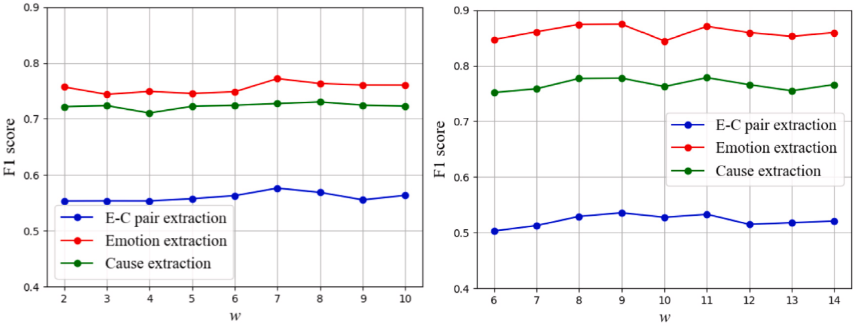

/ig. 6. The influence of the window size control hyper-parameter 𝑤 on the performance of E–C pair extraction.








/ig. 7. An instance of AHMRC prediction on ECF.

Table 7
The influence of the number of ERGAT layers 𝐿 on the performance of E–C pair extraction.
𝐿 | ECF |  |  |  | ConvECPE
 | P | R | F1 |  | P | R | F1
1 | 0.5665 | 0.5687 | 0.5676 |  | 0.5430 | 0.5288 | 0.5358
2 | 0.5928 | 0.5600 | 0.5760 |  | 0.5087 | 0.5388 | 0.5233
3 | 0.5863 | 0.5392 | 0.5618 |  | 0.5163 | 0.5360 | 0.5260
4 | 0.5832 | 0.5488 | 0.5655 |  | 0.5429 | 0.4992 | 0.5202
5 | 0.6008 | 0.4989 | 0.5451 |  | 0.5498 | 0.4908 | 0.5186

surprised tone. When the E–C pair extraction task relies solely on the text-only modality for prediction, it can only identify (𝑈₄, 𝑈₅) and fails to identify the more difficult E–C pairs (𝑈1, 𝑈1) and (𝑈4, 𝑈4). However, by incorporating additional information from the audio and video modalities, the AHMRC framework can correctly identify all potential E–C pairs in the conversation.

Conclusions and future work

In this paper, we propose an adaptive hybrid machine reading comprehension framework for extracting emotion-cause pairs from multimodal conversations. It transforms the MECPEC task into a hybrid two-round machine reading comprehension task that retrieves emotions and their corresponding causes using the global emotion query and the local cause query, respectively. Furthermore, a stacked
multimodal attention submodule is used to fuse the multimodal features contained in the conversations, and an adaptive fusion submodule is designed to adaptively measure and adjust the contributions from mul-timodalities. Extensive experiments have been conducted on the ECF and ConvECPE datasets to demonstrate the accuracy advantage of the proposed AHMRC framework over other state-of-the-art emotion-cause pair extraction methods.
In subsequent research, we plan to design modular visual feature extractors with a focus on facial expressions and body gestures to further enhance the visual emotion extraction ability. In addition, we aim to incorporate pre-trained large language models to enhance causal reasoning ability based on embedded common sense knowledge. Furthermore, the employment of contemporary visual language models constitutes a valuable strategy within the context of the multimodal emotion cause pair extraction task.

CRediT authorship contribution statement

Guorui Li: Writing – review & editing, Supervision, Methodology. Xufeng Duan: Writing – original draft, Software, Formal analysis. Cong Wang: Resources, Investigation. Sancheng Peng: Writing –review & editing, Visualization, Conceptualization.

Declaration of competing interest

The authors declare that they have no known competing financial interests or personal relationships that could have appeared to influence the work reported in this paper.

Acknowledgments

This work was supported by the Laboratory of Language and Artificial Intelligence, Center for Linguistics and Applied Linguistics, Guangdong University of Foreign Studies, China (grant No. LAI202306), the Major Science and Technology Support Program of Hebei Province (grant No. 242Q1602Z), and the Natural Science Foundation of Hebei Province, China, China (grant Nos. F2020501034 and F2022501025).

Data availability

The code is available at https://github.com/liguorui77/AHMRC.

References

Bao, Y., Ma, Q., Wei, L., Zhou, W., Hu, S., 2022. Speaker-guided encoder-decoder framework for emotion recognition in conversation. In: Proceedings of the 31st International Joint Conference on Artificial Intelligence. pp. 4051–4057.
Busso, C., Bulut, M., Lee, C.C., Kazemzadeh, A., Mower, E., Kim, S., Chang, J.N., Lee, S., Narayanan, S.S., 2008. IEMOCAP: Interactive emotional dyadic motion capture database. Lang. Resour. Eval. 42, 335–359.
Cheng, Z., Jiang, Z., Yin, Y., Li, N., Gu, Q., 2021. A unified target-oriented sequence-to-sequence model for emotion-cause pair extraction. IEEE/ACM Trans. Audio Speech Lang. Process. 29, 2779–2791.
Cheng, Z., Jiang, Z., Yin, Y., Wang, C., Ge, S., Gu, Q., 2023. A consistent dual-MRC framework for emotion-cause pair extraction. ACM Trans. Inf. Syst. 41 (4), 1–27.
Ding, Z., Xia, R., Yu, J., 2020a. ECPE-2D: Emotion-cause pair extraction based on joint two-dimensional representation, interaction and prediction. In: Proceedings of the 58th Annual Meeting of the Association for Computational Linguistics. pp. 3161–3170.
Ding, Z., Xia, R., Yu, J., 2020b. End-to-end emotion-cause pair extraction based on sliding window multi-label learning. In: Proceedings of the 2020 Conference on Empirical Methods in Natural Language Processing. pp. 3574–3583.
Fu, C., Qian, F., Su, K., Su, Y., Wang, Z., Shi, J., Liu, Z., Liu, C., Ishi, C.T., 2025a.
HiMul-LGG: A hierarchical decision fusion-based local–global graph neural network for multimodal emotion recognition in conversation. Neural Netw. 181, 106764.
Fu, Y., Yan, X., Chen, W., Zhang, J., 2025b. Feature-Enhanced Multimodal Interaction model for emotion recognition in conversation. Knowl.-Based Syst. 309, 112876.
Gan, C., Tang, Y., Fu, X., Zhu, Q., Jain, D.K., García, S., 2024. Video multimodal sentiment analysis using cross-modal feature translation and dynamical propagation. Knowl.-Based Syst. 299, 111982.
Ghosal, D., Majumder, N., Poria, S., Chhaya, N., Gelbukh, A., 2019. DialogueGCN: A graph convolutional neural network for emotion recognition in conversation. In: Proceedings of the 2019 Conference on Empirical Methods in Natural Language Processing. pp. 154–164.
Gu, X., Zhou, Z., Meng, Z., Li, J., Gomes, T., Tavares, A., Xu, H., 2024. EmoPrompt-ECPE: Emotion knowledge-aware prompt-tuning for emotion-cause pair extraction. In: Proceedings of the 2024 Joint International Conference on Computational Linguistics, Language Resources and Evaluation. pp. 5678—-5688.
Guo, L., Song, Y., Ding, S., 2024. Speaker-aware cognitive network with cross-modal attention for multimodal emotion recognition in conversation. Knowl.-Based Syst. 296, 111969.
Hu, D., Hou, X., Wei, L., Jiang, L., Mo, Y., 2022a. MM-DFN: Multimodal dynamic fusion network for emotion recognition in conversations. In: Proceedings of 2022 IEEE International Conference on Acoustics, Speech and Signal Processing. pp. 7037–7041.
Hu, G., Lin, T., Zhao, Y., Lu, G., Wu, Y., Li, Y., 2022b. UniMSE: Towards unified multimodal sentiment analysis and emotion recognition. In: Proceedings of the 2022 Conference on Empirical Methods in Natural Language Processing. pp. 7837–7851.
Hu, J., Liu, Y., Zhao, J., Jin, Q., 2021. MMGCN: Multimodal fusion via deep graph convolution network for emotion recognition in conversation. In: Proceedings of the 59th Annual Meeting of the Association for Computational Linguistics. pp. 5666–5675.
Hu, G., Zhu, Z., Hershcovich, D., Seifi, H., Xie, J., 2024. UniMEEC: Towards unified multimodal emotion recognition and emotion cause. In: Proceedings of the 2024 Conference on Empirical Methods in Natural Language Processing. pp. 5248–5261.
Jain, D.K., Qamar, S., Sangwan, S.R., Ding, W., Kulkarni, A.J., 2024a. Ontology-based natural language processing for sentimental knowledge analysis using deep learning architectures. ACM Trans. Asian Low-Resource Lang. Inform. Process. 23 (1), 1–17.
Jain, D.K., Rahate, A., Joshi, G., Walambe, R., Kotecha, K., 2024b. Employing co-learning to evaluate the explainability of multimodal sentiment analysis. IEEE Trans. Comput. Soc. Syst. 11 (4), 4673–4680.
Joshi, A., Bhat, A., Jain, A., Singh, A., Modi, A., 2022. COGMEN: Contextualized GNN based multimodal emotion recognition. In: Proceedings of the 2022 Conference of the North American Chapter of the Association for Computational Linguistics. pp. 4148–4164.
Li, B., Fei, H., Li, F., Chua, T.s., Ji, D., 2024. Multimodal emotion-cause pair extraction with holistic interaction and label constraint. ACM Trans. Multimed. Comput. Commun. Appl. 1–20. http://dx.doi.org/10.1145/3689646.
Li, B., Fei, H., Li, F., Chua, T.s., Ji, D., 2025a. Multimodal emotion-cause pair extraction with holistic interaction and label constraint. ACM Trans. Multimed. Comput. Commun. Appl. 21 (10), 1–20.
Li, W., Li, Y., Pandelea, V., Ge, M., Zhu, L., Cambria, E., 2023a. ECPEC: Emotion-cause pair extraction in conversations. IEEE Trans. Affect. Comput. 14 (3), 1754–1765.
Li, M., Shi, J., Bai, L., Huang, C., Jiang, Y., Lu, K., Wang, S., Hancock, E.R., 2025b. FrameERC: Framelet transform based multimodal graph neural networks for emotion recognition in conversation. Pattern Recognit. 161, 111340.
Li, J., Wang, X., Lv, G., Zeng, Z., 2023b. GA2MIF: graph and attention based two-stage multi-source information fusion for conversational emotion detection. IEEE Trans. Affect. Comput. 15 (1), 130–143.
Li, J., Wang, X., Lv, G., Zeng, Z., 2023c. GraphMFT: A graph network based multimodal fusion technique for emotion recognition in conversation. Neurocomputing 550, 126427.
Liu, C., Niu, C., Xie, J., Jia, Y., Zan, H., 2023a. Emotion-cause pair extraction in conversations based on multi-turn MRC with position-aware GCN. In: Processings of 2023 International Conference on Asian Language Processing. pp. 25–30.
Liu, J., Zhang, Z., Guo, Z., Jin, L., Li, X., Wei, K., Sun, X., 2023b. Emotion-cause pair extraction with bidirectional multi-label sequence tagging. Appl. Intell. 53 (24), 30400–30415.
Liu, X., Zhang, J., Zhang, H., Xue, F., You, Y., 2023c. Hierarchical dialogue understanding with special tokens and turn-level attention. In: Proceedings of the 11th International Conference on Learning Representations. pp. 1–7.
Ma, J., Nazeer, C.H., Farzana, K., Yang, G., Ullah, K.S., Sujit, B., Ullah, K.Z., Faheem, K., 2025. MULTICAUSENET temporal attention for multimodal emotion cause pair extraction. Sci. Rep. 15 (1), 19372.
Mai, H., Zhang, X., Wang, J., Zhou, X., 2024. A machine reading comprehension model with counterfactual contrastive learning for emotion-cause pair extraction. Knowl. Inf. Syst. 66, 3459–3476.
Peng, S., Zeng, R., Liu, H., Cao, L., Wang, G., Xie, J., 2024. Deep broad learning for emotion classification in textual conversations. Tsinghua Sci. Technol. 29 (2), 481–491.
Poria, S., Hazarika, D., Majumder, N., Naik, G., Cambria, E., Mihalcea, R., 2019. MELD: A multimodal multi-party dataset for emotion recognition in conversations. In: Proceedings of the 57th Annual Meeting of the Association for Computational Linguistics. pp. 527–536.
Quan, X., Wu, S., Chen, J., Shen, W., Yu, J., 2024. Multi-party conversation modeling for emotion recognition. IEEE Trans. Affect. Comput. 15 (3), 751–768.
Shi, T., Huang, S.L., 2023. MultiEMO: An attention-based correlation-aware multimodal fusion framework for emotion recognition in conversations. In: Proceedings of the 61st Annual Meeting of the Association for Computational Linguistics. pp. 14752–14766.
Song, X., Zou, D., Yu, Y., Zhang, X., 2023. FW-ECPE: An emotion-cause pair extraction model based on fusion word vectors. In: Proceedings of 2023 International Joint Conference on Neural Networks. pp. 1–7.
Su, X., Huang, Z., Zhao, Y., Chen, Y., Dou, Y., Pan, H., 2023. Recent trends in deep learning based textual emotion cause extraction. IEEE/ACM Trans. Audio Speech Lang. Process. 31, 2765–2786.
Tran, D., Bourdev, L., Fergus, R., Torresani, L., Paluri, M., 2015. Learning spatiotem-poral features with 3D convolutional networks. In: Proceedings of 2015 IEEE International Conference on Computer Vision. pp. 4489–4497.
Tsai, H., Bai, S., Liang, P.P., Kolter, J.Z., Morency, L.P., Salakhutdinov, R., 2019. Multimodal transformer for unaligned multimodal language sequences. In: Proceedings of the 57th Annual Meeting of the Association for Computational Linguistics. pp. 6558–6569.
Tu, G., Xie, T., Liang, B., Wang, H., Xu, R., 2024. Adaptive graph learning for multimodal conversational emotion detection. In: Proceedings of the 38th AAAI Conference on Artificial Intelligence. pp. 19089–19097.
Wang, F., Ding, Z., Xia, R., Li, Z., Yu, J., 2023. Multimodal emotion-cause pair extraction in conversations. IEEE Trans. Affect. Comput. 14 (3), 1832–1844.
Wei, P., Zhao, J., Mao, W., 2020. Effective inter-clause modeling for end-to-end emotion-cause pair extraction. In: Proceedings of the 58th Annual Meeting of the Association for Computational Linguistics. pp. 3171–3181.
Xia, R., Ding, Z., 2019. Emotion-cause pair extraction: A new task to emotion analysis in texts. In: Proceedings of the 57th Annual Meeting of the Association for Computational Linguistics. pp. 1003–1012.
Xiang, Y., Wang, L., Tan, X., Guo, J., 2025. Dual-level constraint based distributed graph convolution network for multimodal emotion recognition in conversation. Neurocomputing 618, 128937.
Xu, S., Jia, Y., Niu, C., Zan, H., 2022. MMDAG: Multimodal directed acyclic graph network for emotion recognition in conversation. In: Proceedings of the 13th Language Resources and Evaluation Conference. pp. 6802–6807.
Yang, Z., Li, X., Cheng, Y., Zhang, T., Wang, X., 2024. Emotion recognition in conversation based on a dynamic complementary graph convolutional network. IEEE Trans. Affect. Comput. 15 (3), 1567–1579.
Zhao, W., Zhao, Y., Qin, B., 2022. MuCDN: Mutual conversational detachment network for emotion recognition in multi-party conversations. In: Proceedings of the 29th International Conference on Computational Linguistics. pp. 7020–7030.

Zhou, C., Song, D., Xu, J., Wu, Z., 2022. A multi-turn machine reading comprehension framework with rethink mechanism for emotion-cause pair extraction. In: Proceedings of the 29th International Conference on Computational Linguistics. pp. 6726–6735.
Zhuang, L., Wayne, L., Ya, S., Jun, Z., 2021. A robustly optimized BERT pre-training approach with post-training. In: Proceedings of the 20th Chinese National Conference on Computational Linguistics. pp. 1218–1227.

